Collective Encounters

Trustee Information Pack

Collective Encounters is seeking new trustees to join our board. Do you have experience of our participatory programme? Or, do you live in the Liverpool City Region and are interested in community development? Or are you seeking opportunities within charity governance? If any of these apply we would love to hear from you.
Trustee meetings are held 4 to 6 times per year. We think it’s important for our trustees to come along to workshops and performances and the occasional additional meeting also.
Trustees help guide and support the charity in achieving its ambitions. More information about Collective Encounters is contained below.
If you require this information in an alternative format email
admin@collective-encounters.org.uk or call 0151 345 6266 for a chat!

Who are we?
Collective Encounters was established in 2004. We deliver participatory theatre programmes with geographical communities and communities of interest across the Liverpool City Region. The company works with people who are directly affected by poverty and inequality, predominately in the Northwest, using live and digital theatre experiences to tell the untold stories of our time, to empower and to develop capacity for positive change.
We define change as:
Personal: by increasing the confidence, self-esteem and skills of the participants that take part in our workshops and performances.
Social: challenging stereotypes, increasing civic engagement, and raising awareness of the experiences of our participants amongst the local community and the general public.
Political: opening dialogue with decision makers to challenge the effect of local and national policy and the economic system on those with direct experience of poverty.
Since 2005, Collective Encounters has created one new production annually performing to over 80,000 people nationally and internationally. Productions have brought to the fore issues and themes such as health and wealth inequality, poverty, homelessness, rise in hate crimes against vulnerable people, mental health, human trafficking, globalism, climate change, and neoliberalism.
“
Each year Collective Encounters enables 4,000 people to take part in high quality arts activities including Theatre for Social Change workshops, weekly youth theatre sessions, weekly acting sessions for older people, political theatre writing courses, masterclasses from nationally renowned artists, symposiums, and conferences. Participants are diverse and include looked after children and young people, young carers, young homeless people, people in exile, women who have experienced domestic violence, homeless people, those with mental health issues, carers, older people accessing befriending services, artists, policy makers and academics. These activities have developed skills, built confidence, and inspired communities.

Our staff and board
Our core staff team comprises Sarah Thornton (Artistic Director), Annette Burghes (Executive Director), Abi Horsfield (Outreach Director), Tessa Buddle (General Manager), Aidan Jolly (Radical Makers Director) and Marianne Matusz (Sector Development Coordinator) alongside a number of freelance associates who lead and support artistic programmes.
Our current board members are: Jim Johnson (Chair), Anna Jones (Vice-chair), Graham Boxer, Jamie Beddard, Ithalia Forel, Anya Winful, June Hudson, and Anthony Scott

Our funders and networks
Collective Encounters is a National Portfolio Organisation of Arts Council England (confirmed to March 2023) and is supported by the Liverpool City Council Culture and Arts Investment Programme. Project funders include Paul Hamlyn Foundation, Esmée Fairbairn Foundation, PH Holt Foundation, and Liverpool Charity and Voluntary Services.
We are members of Creative Organisations of Liverpool (COoL) and ArtWorks Alliance

Our current projects include:
Radical Makers
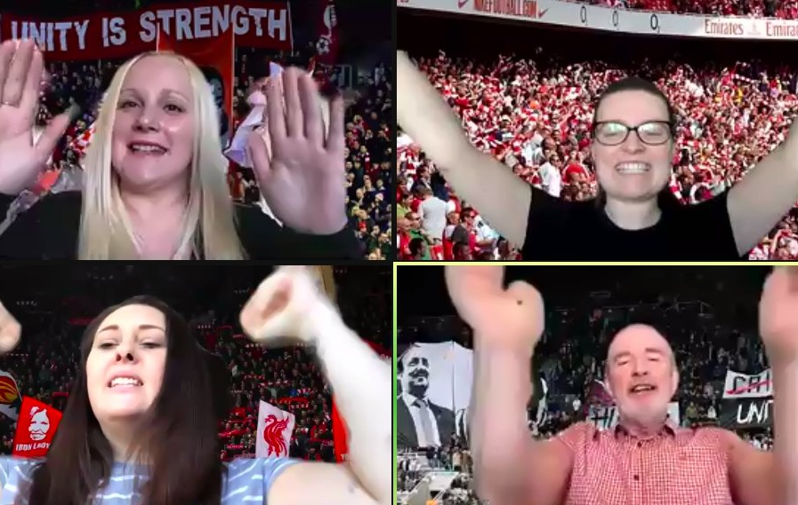
Women in Action
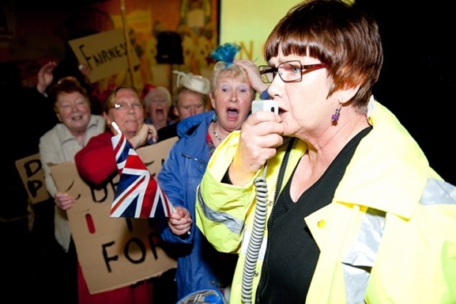
Above & Beyond
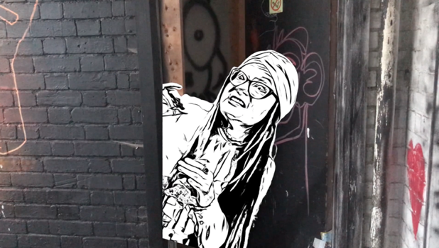

Centre for Excellence
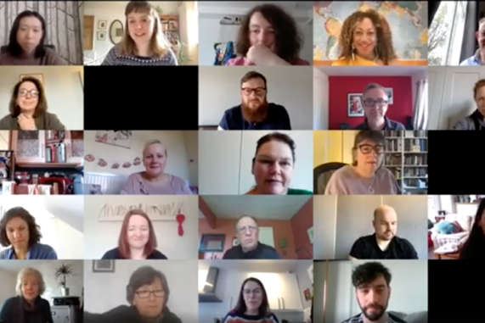
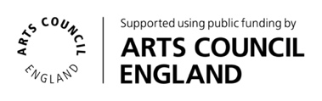
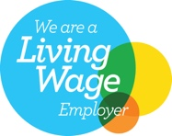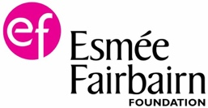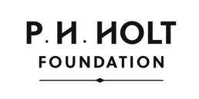

Collective Encounters’ manifesto
We are Collective Encounters, and we make Theatre for Social Change.
We are artists and activists, thinkers, and doers.
We are informed by diverse experience and common cause.
We are rooted in communities and guided by our ethics.
We are kind and welcome all.
We strive for excellence and the continual development of our work.

We believe that too many people in our world are left behind while a few race far ahead; the odds stacked.
We believe that the time for change is now. It doesn’t have to be like this. That there are different choices; better, fairer ways.

We believe that theatre is a powerful tool to challenge the system and redress the inequalities of our times.
We use theatre to entertain, engage, excite and delight.
To expose realities, challenge the status quo, champion human rights.
To tell stories that are often ignored.
To bring people together to share ideas, explore difference and find connections.
To spark debate, facilitate conversations.
To imagine alternatives, rehearse change and play out new possibilities.
We use theatre to provoke action.

We are cooperative and collaborative.
We work within and across disciplines, sectors, cultures and countries,
To share our practice, learn from our peers and foster new thinking;
To extend our reach, deepen our impact and enhance our art;
To find solidarity.
We are Collective Encounters and we dream of a brighter future.

Our priorities for 2022-23

Anti-Racism
Collective Encounters proactively seeks to include diverse and under-represented voices, and to tackle and educate those whose actions are seen as discriminatory. Our anti-racism pledge for 2022-23 includes commitments to increase opportunities for diverse voices, educate ourselves, decolonise our Centre for Excellence, and create safe spaces free from micro-aggressions.

Embedding Equality, Diversity & Inclusion (EDI)
Each year Collective Encounters prepares an Equality, Diversity & Inclusion Action Plan in areas that include skills and expertise, organisational culture, mission and values, recruitment and employment practices, communications and community relevance and engagement

Access
Our 2022-23 programme is designed around specific measures and actions that aim to minimise the barriers people experience in engaging in the arts, such as providing hybrid participation opportunities, supporting digital inclusion, ensuring physical access, and creating safe spaces.

Quality, Change and Evaluation
We believe that our society is inherently unequal, and our work focuses on tackling this. Collective Encounters measures its impact against a series of quality and change indicators, which define the framework for quality in relation to process, product, and management.

Co-creation
We will continue evolving the relationship between Collective Encounters’ mission, values, programme and those who participate in the work, to ensure the company gives voice and responds to the needs of the local community, engages in meaningful dialogue and allows participants to develop skills.

Climate & Ecological Emergency & Climate Justice
Collective Encounters believes creativity and culture can contribute to creating a regenerative future that protects the planet and sustains everyone, everywhere. In 2022-23 we will take action to limit our own carbon emissions, advocate and educate for a sustainable future for all.

Key ambitions
- Increase the ethnic diversity and broader diversity of our audience, participants, workforce and the wider arts and cultural workforce through a well-designed programme.
- Deliver a meaningful and interconnected Theatre for Social Change participation programme.
- Find new ways to engage and connect those who are most isolated, in the cultural life of the place they live.
- Make a significant contribution to the Arts for Social Change sector by delivering training events, building networks, advocating for the arts, and publishing high-quality evidence of approaches and impacts.
- Continue to build a business model that is ethical, sustainable, and resilient to social, political, technological and economic challenges and opportunities

More about being a Trustee
We are looking for new trustees to join our board. We are seeking people who can offer passion, knowledge and expertise in our priority areas such as anti-racism; equality, diversity and inclusion; accessibility; co-creation; climate justice; and support us to meet our future ambitions.
We are particularly interested in the expertise brought by people who are previous or current participants of Collective Encounters and those who are currently under-represented in the governance of arts organisations including Black people, people of colour, those from ethnic communities, disabled people, and people from economically disadvantaged backgrounds.
We are also open to applications from those with specialist knowledge, energy and dedication, who can make a contribution at a strategic level. Trustees are
- Responsible for ensuring that the organisation fulfils its charitable objectives and lives up to its manifesto.
- Responsible for the performance of the charity and its culture and ensuring that Collective Encounters complies with all legal and regulatory requirements.
- Guardians of the charity’s assets, both tangible and intangible, taking all due care over their security, deployment, and proper application, and ensure that the organisation’s governance is of the highest possible standard.
- Strategic leaders of the organisation, using their skills, backgrounds, and contacts to assist the organisation in continuing to make a real difference and ensure its sustainability.

Time Commitment
- A two-hour online board meeting every two to three months
- An hour or so to review paperwork and keep in touch
- Coming along to Collective Encounters’ workshops and events when you can.

Expenses
- This is a voluntary role
- Out of pocket expenses such as childcare, travel to allow you to attend meetings and events.

Registration and Induction
On becoming a trustee, you will be provided with the Collective Encounters business plan, latest set of accounts and most recent board papers, along with some forms to complete, including:
- Declaration of willingness to serve
- Declaration of material interests
- Application for a Disclosure and Barring Service (DBS) check if you do not already have one
You will become a registered Director of the company with Companies House, and a registered Trustee with the Charity Commission. Your name, address, date of birth, nationality, and occupation will be shared with these bodies, but only your name will be public.

How to apply
To express an interest in being a Collective Encounters Trustee, please send an email or video explaining why you are interested in the role and a little more about you. Let us know the aspects of the organisation you are particularly interested in. If you have a CV send that in too. You are also welcome to send this information as a video recording.
If you require this information pack in an alternative format, or have any other questions about the role, please email. There’s no deadline and we promise to get back to you within 3 weeks of you making an application.
admin@collective-encounters.org.uk or call 0151 354 6266.

